For centuries there has been a battle between the people of God and sexual immorality. Constantly, throughout the Bible, we read of instances where God sets standards for sexual morality for His children and chastises those who practice otherwise. Paul also makes numerous statements about how important it is that the people of God flee from sexual immorality, or else face eternal consequences.

One of the most prevalent battles we are fighting in the arena of sexual immorality today is pornography. Many churches have been on the frontlines, providing support to men who struggle with pornography addiction, but most women are left to deal with it in silence. Though women are not as vocal about the issue as men, statistics show that 33-40% of the people that visit pornographic websites are women. Within the church alone, 34% of women admit to intentionally visiting these kinds of sites.

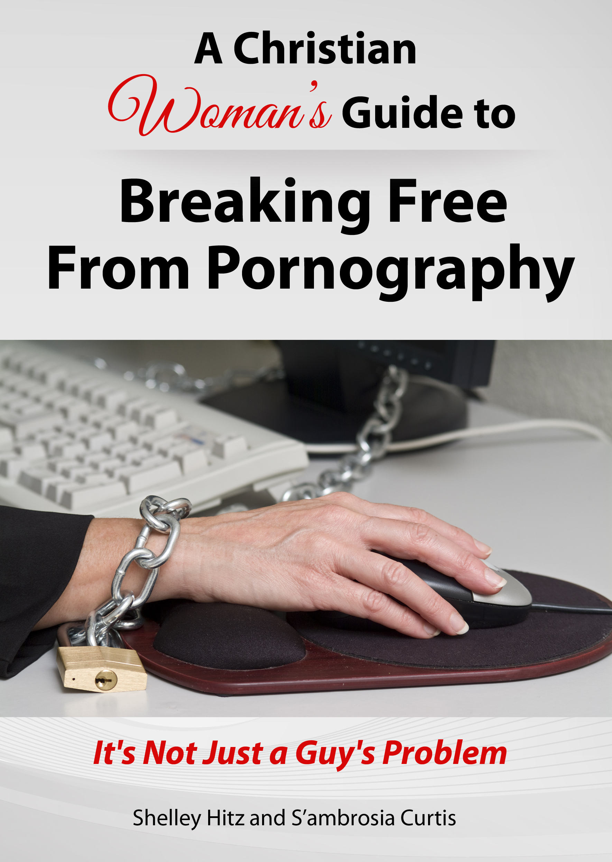
One resource I would like to share with you is a book written for Christian women who struggle with pornography entitled, “A Christian Woman’s Guide to Breaking Free from Pornography: It’s Not Just a Guy’s Problem” by Shelley Hitz and S’ambrosia Curtis.

Both of the authors share their testimonies of how Christ set them free in this area and also present a good deal of research about the influence pornography has on modern society as well as its spiritual and psychological effects. This information is followed by testimonies of other women who have experienced freedom in this area of their lives, as well as practical advice on how to overcome this addiction.

Both the Kindle and print edition are available on Amazon.

Kindle: http://www.christianwomenandporn.com/amazon
Print: http://www.christianwomenandporn.com/print

I encourage you to consider utilizing this book as a resource in your ministry. If you have any questions regarding the book, how to implement it, or anything else, you can contact the authors here: http://www.christianwomenandporn.com/contact/

Sincerely,

